**CHAPTER 1: INTRODUCTION**

**Introduction**

The world is becoming more advanced nowadays. Everything that is manual is being transferred digitally for faster speed and better work in every aspect, like education, business, government work, hospitals. Whenever you visit a hospital in a case of emergency or any health-related problem, it seems that you don't get beds on time, the facilities and equipment are not available, and you were not aware of these things previously just because there is no facility that provides you information regarding whether the hospital is available or not. Many patients suffer because of this situation, and so many die also, just because the ICU beds in the hospitals are occupied and they have to wait in the general ward for their turn, and due to the delay in time, many people lose their lives.

The project uses Python, Flask, SQLAlchemy, HTML, CSS, and JavaScript to create this website successfully. We take data from hospitals by providing a registration form which will be fielded by the hospital management department. The data is going to be stored in a database, and then we provide information to users as per their requirements.

**1.1 Overview**

The project is based on the data fields by hospitals, which we store in our database and provide the user requirements with particular hospital information because hospital management needs to insert the right data and upgrade the data timely so people get the right information. The website is made in such a way that users have the option to choose between private and government hospitals. Users can also search for a hospital directly if they want, and we will provide all the necessary information regarding that particular hospital, including all the equipment facilities, doctor's availability, and all other information.

**1.2 Background and Motivation**

ICU and ventilator facilities are very important to helping those people who need treatment very quickly, because if any patient arrives at that hospital, its ICU beds are already occupied for operation. So they have to wait in the general ward until the operation is finished, putting their lives in danger; or maybe in a case where the bed is available but the equipment like a ventilator is not available.

Object Detection and recognition becomes a necessity when there is a need of automation, where the identification is done by machines instead of doing it manually for better performance and reliability. Normally, there are people hired specially for counting the number of students and vehicles that enter in a college everyday and maintain their records manually in a register. Automation by this system provides a better way to perform the same work.

**1.3 Problem Statement and Objectives**

To get the information about the occupancy of beds and necessary equipment for the patients in a particular hospital, especially in emergency cases. An electronic system will be brought into usage to identify these and make patients aware and easy to find.

Thus, the system implemented has the following objectives :

* **Objective 1:** To count the number of beds are present in the hospital.
* **Objective 2:** To provide information about facilities present in the hospitals.

**1.4 Scope of the Project**

As the project uses hospital information by their own administration we can use this website widely in other city also , Private hospitals and Government hospital both come under this project.

**1.5 Team Organization**

**Ansh Joshi:** Working in a team is a fantastic opportunity, and I am grateful that college provided me the opportunity to work on a project. I analyze the project, and as a front-end developer, it's my responsibility to make the website eye-catching and highly interactive so users don't have any problems.

**Bhavik Mundra:** This is my first project, and I am very excited and enthusiastic to work on it. I overview the topic, and as a backend developer, I have to create all the logic correctly and link the frontend, backend, and database successfully.

**Bhavik Sharma:** My role is to create a database to collect data and handle the documentation portion of the project while working with a fantastic team to get tremendous knowledge and expertise.

**Bhavika Darpe:** I oversee the team and manage the backend and database integration for the project. I can state with some confidence that this experience will be useful to me in the future.

**1.6 Report Structure**

The project Hospital Bed Availability Checking is primarily concerned with the Image processing in real-time and the whole project report is categorized into five chapters.

**Chapter 1: Introduction**- introduces the background of the problem followed by Smart India Hackathon. The chapter describes the objectives, scope and applications of the project. Further, the chapter gives the details of team members and their contribution in development of the project which is then subsequently ended with a report outline.

**Chapter 2: Review of Literature**- explores the work done in the area of Project undertaken and discusses the limitations of the existing system and highlights the issues and challenges of the project area. The chapter finally ends up with the requirement identification for present project work based on findings drawn from reviewed literature and end user interactions.

**Chapter 3: Proposed System** - starts with the project proposal based on requirement identified, followed by benefits of the project. The chapter also illustrates the software engineering paradigm used along with different design representations. The chapter also includes a block diagram and details of major modules of the project. Chapter also gives insights of different types of feasibility study carried out for the project undertaken. Later it gives details of the different deployment requirements for the developed project.

**Chapter 4: Implementation** - includes the details of different Technology/ Techniques/ Tools/ Programming Languages used in developing the Project. The chapter also includes the different user interfaces designed in the project along with their functionality. Further it discusses the experiment results along with testing of the project. The chapter ends with evaluation of the project on different parameters like accuracy and efficiency.

**Chapter 5: Conclusion** - Concludes with objective wise analysis of results and limitation of present work which is then followed by suggestions and recommendations for further improvement.

**CHAPTER 2. REVIEW OF LITERATURE**

Review of Literature



**2.1 Preliminary Investigation**

The increasing cost of education is leaving very limited options to students. Fortunately, scholarships from both public and private sectors are there to provide opportunities to numerous deserving students. Educational institutions are processing thousands of applications and managing existing scholars during the admission period. As a result, scholarship management software has become an essential tool to ensure that each scholar receives benefits accordingly.

**2.1.1 Current System**

Current Systems for Scholarship management includes many softwares but Indian  portals for managing students information as well as scholarships information given by the union government ,state government , private sector are very limited.

1. **National Scholarship Portal:**

NSP is a digital scholarship platform that carries multiple scholarships offered by the central government, state governments and different government agencies like UGC (University Grants Commission). The NationalScholarship Portal hosts about 104 scholarship schemes worth hundreds of crores for the scholarship seekers registered on the platform.  According to officials, the platform has, so far, helped the government implement and disburse scholarships worth more than INR 2,700 crores. The platform boasts of more than 127 Lakh applications out of which over 84 Lakh applications are verified also.

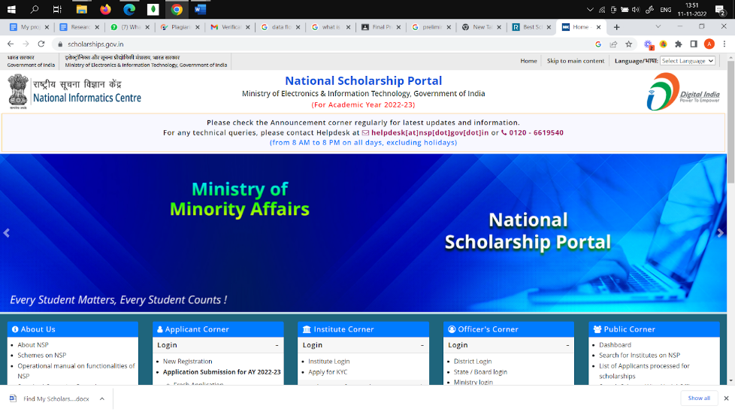

* **Advantages:**

* All governmental Scholarships including central,state ,union territories are provided within the system with deadlines.

* Language translation available for different users across the country.

* **Disadvantages:**

* International Scholarships and scholarships by non-governmental organizations are not available.

* Only site managed for all scholarships hence increased load.

* **Reference link:**

[**https://scholarships.gov.in/**](https://scholarships.gov.in/)

1. **Scholarship Portal:**

Scholarships.com offers a simple and accessible approach to finding and applying for scholarships for students of all ages. Our tried, tested and acclaimed search engine delivers targeted lists of scholarships for the investment of just a few minutes. This site offers free college scholarship search and financial aid information resources on the Internet and has been recognized by high schools, colleges and universities nationwide, among others.

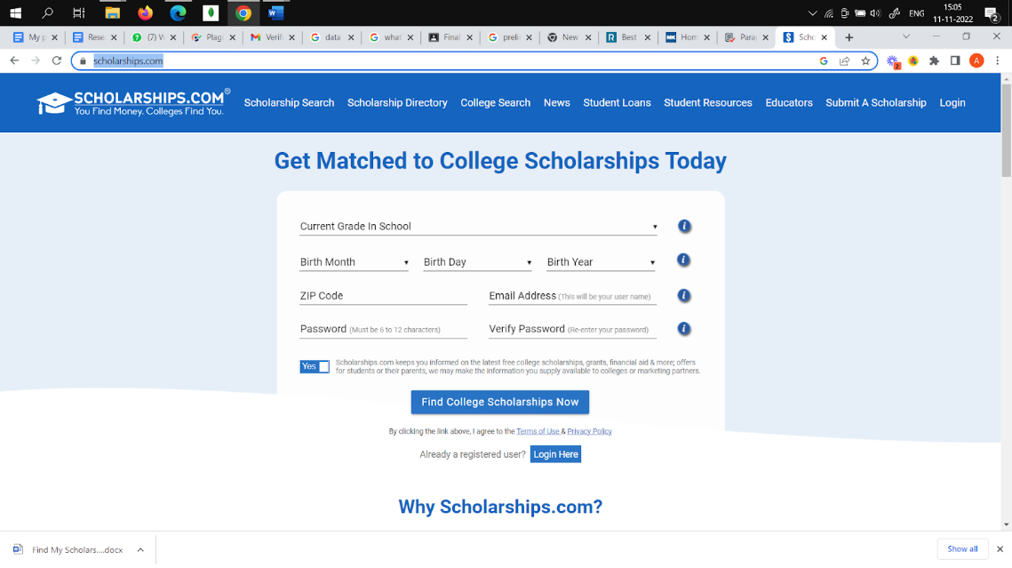

* **Advantages:**

* Contains all useful information required for applying for a scholarship.

* good bonds with colleges and scholarship providers to help student get good benefits.

* **Disadvantages:**
* Indian Colleges and Universities are not included in the list of colleges on the portal.

* User Interface should be upgraded.

* **Reference link:**

[**https://www.scholarships.com/**](https://www.scholarships.com/)

1. **Scholarship Management Software:**

Submit.com is submission management software that aims to make application administration, data analytics, and compliance easier. From government organizations to TV and film production enterprises, the platform is ideal for any institution that collects inputs from a large number of individuals. Educational institutions may use their capabilities to handle education programs, ranging from kindergarten to post-graduate. It is scalable to any scholarship program on a single common platform, making scholarship administration and monitoring easier.

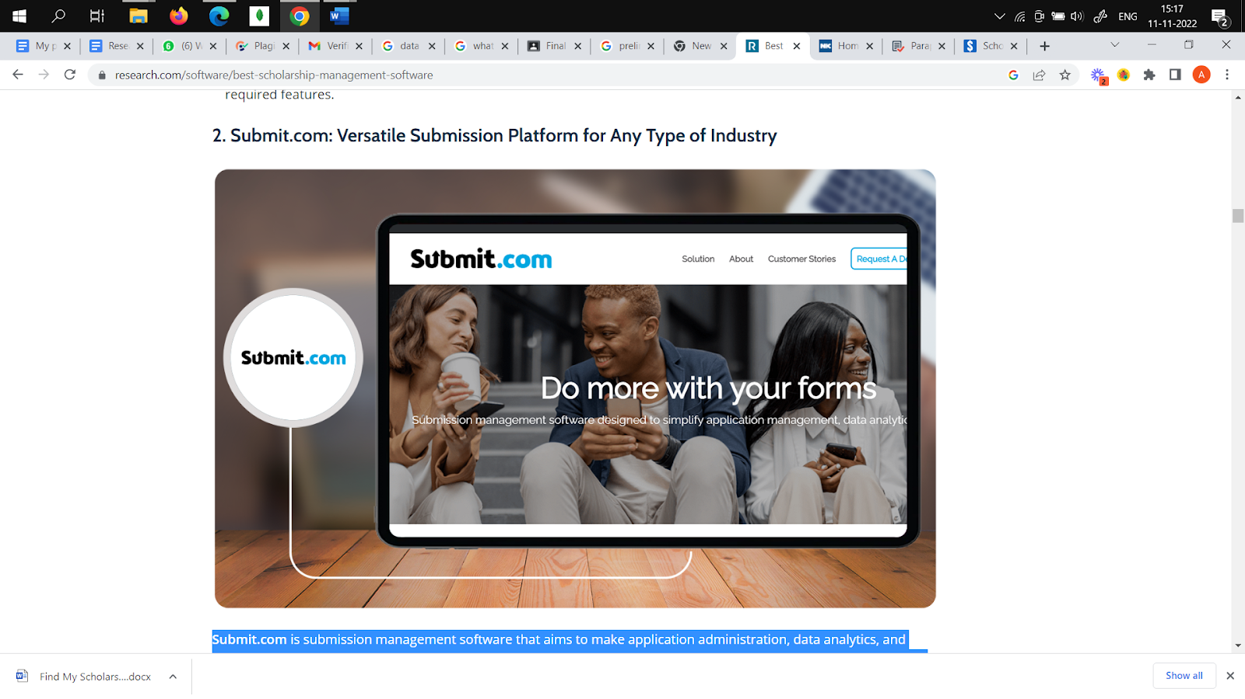

* **Advantages:**
* The platform adapts to any type of program, including student admissions, scholarships and fellowships, research programs, accreditations, grants, and student placements.
* Users can streamline their selection process using multiphase submissions, autoscoring, and auto-tagging features.

* **Disadvantages:**
* Not free of cost
* Doesn’t contain information about private scholarships.

* **Reference link:**

<https://submit.com/>

***al-Time Object Detection and Recognition***

**2.2 Limitations of Current System**

Current systems Lacks information about all scholarships in the Country at the same time. In one portal if central scholarships are present then it might be missed out in state  scholarships or any other non-governmental scholarships.There are portals where governmental scholarships are present but scholarships given by private institutions like some non-governmental organizations are not present.

One major shortcoming of existing system is that there is only one functioning system under government of India for management of scholarships that is NSP, although, state government is also managing their portals but just for their state.Students  studying in another state and willing to apply for their dont have much awareness about their portals . So, there is a need for a system that is accessible for all people across the country.

**2.3 Requirement Identification and Analysis for Project**

* Various studies and work has been done in the field of management of Information . It's not easy to manage huge amounts of data from disparate sources. so, a system is required to manage this much amount of data . The review of literature leads to draw certain major findings which are as under :

* Study of how to manage scholarship data ends up by creating a website to store information related to the same .For creating a portal, study of databases is done ,study of how backend work and connect frontend with databases. Study of appropriate technology is done in order to make process easier and to ensure proper working of the project.

* Out of many technologies , Flask was chosen as the technology to work on for backend work. For frontend , HTML ,CSS , Bootstrap is used to make the website attractive and well functioning.

**2.3.1 Conclusion**

This chapter reviews the literature surveys that have been done during the research work. The related work that has been proposed by many researchers has been discussed. The research papers related to Information Management and Scholarship Management system were studied and decisions were made to use Flask and FlaskSQLAlchemy as the backend support for effective functioning of the project.

**CHAPTER 3 PROPOSED SYSTEM**

Proposed System

**3.1 The Proposal**

The proposal is to deploy a portal which consists of all types of scholarships  including central, state,union territories and international scholarships and some non-governmental  organization’s scholarships.Now users can filter out their Scholarships and compare their scholarships by just one click. This will not only just help the scholarship holders but also help scholarship providers to feature their scholarships at a big level. The purpose is to spread awareness about scholarships and reduce manual work and manpower for selecting scholarships for education. This portal shows scholarships and sends mail to registered users about their activity.Proposed system is built to provide authenticated and updated information at the right time.

**3.2 Benefits of the Proposed System**

* User Friendly and interactive.
* All information is just one click away from users.
* Registration is simple and easy to do.
* NGOs get a golden opportunity to implement their ideas freely.
* Students now have a chance to apply for more scholarships.
* Awareness increases and consequently contribution towards the education sector increases.
* Deserving students won’t miss out on opportunities as deadlines are mentioned on portal and updated timely.
* Students and scholarship holders can make better decisions based on comparative study by scrolling out various different types of scholarships.
* One major problem arises when we are searching for scholarships is that we get wrong or not working URLs. This system overcomes those limitations by updating the system timely.

**3.3 Design Representation**

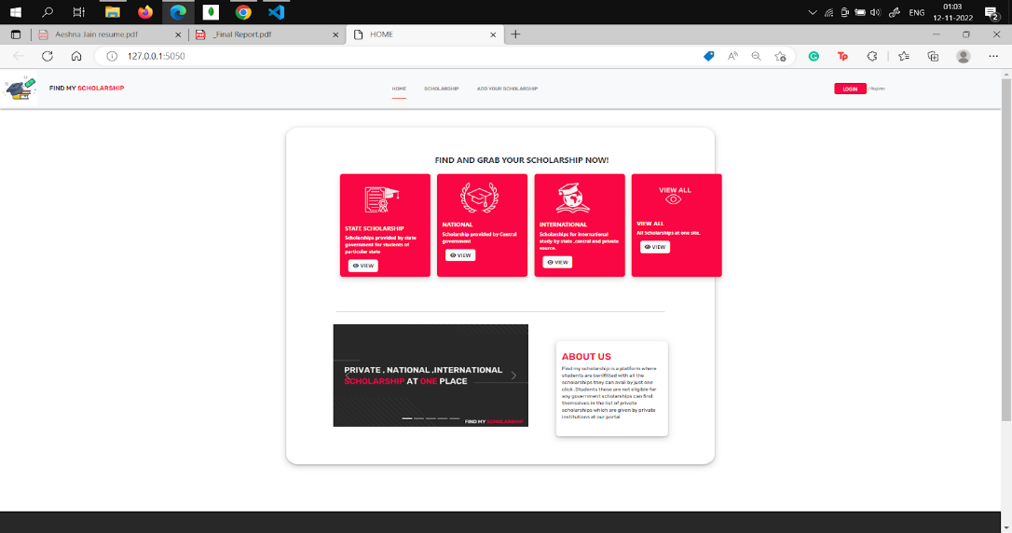

**Figure :1 Home page**

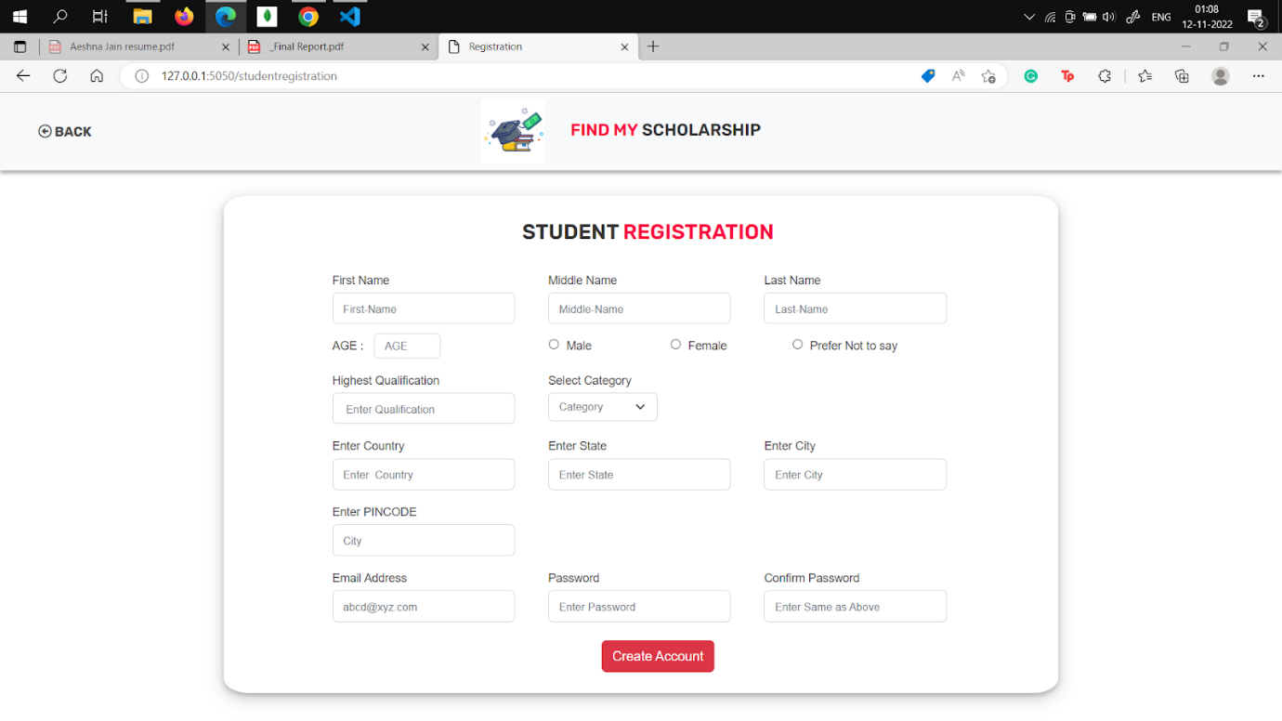

**Figure: 2 Student  Registration Page**

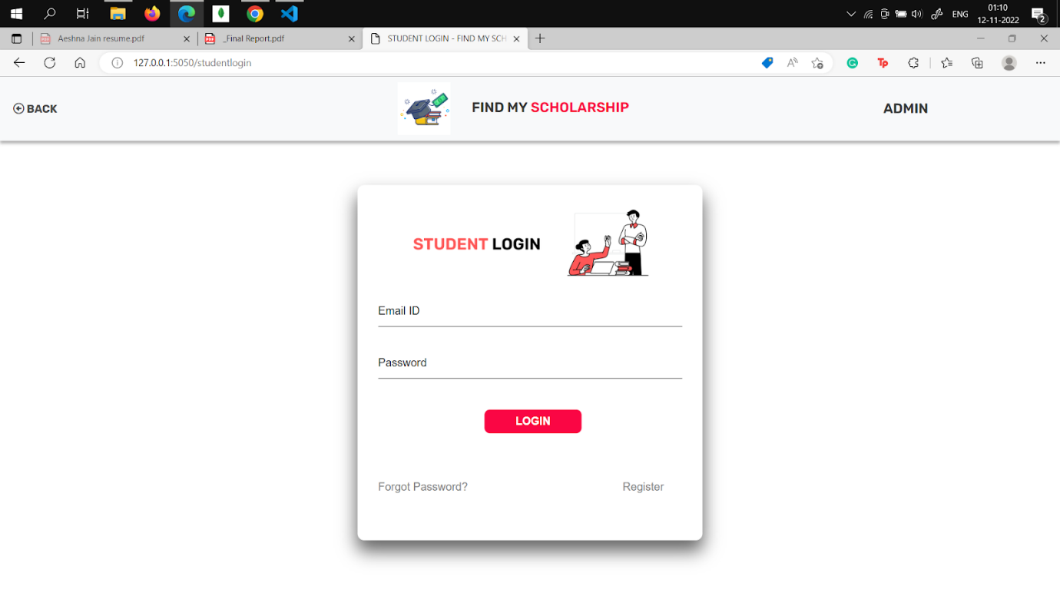

**Figure:3 Student Login Page**

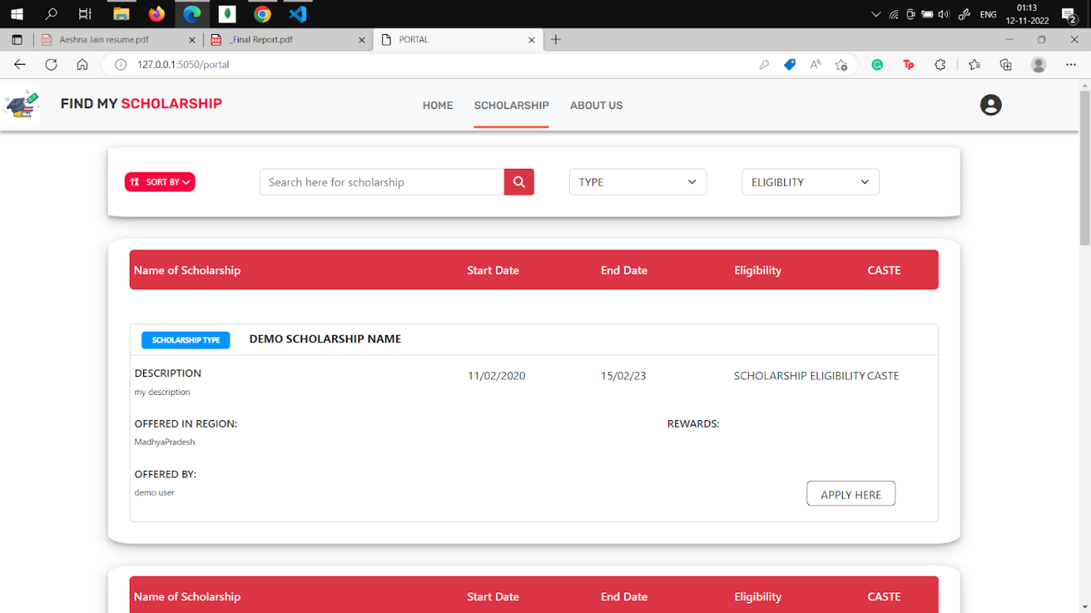

**Figure: 4 Portal Page**

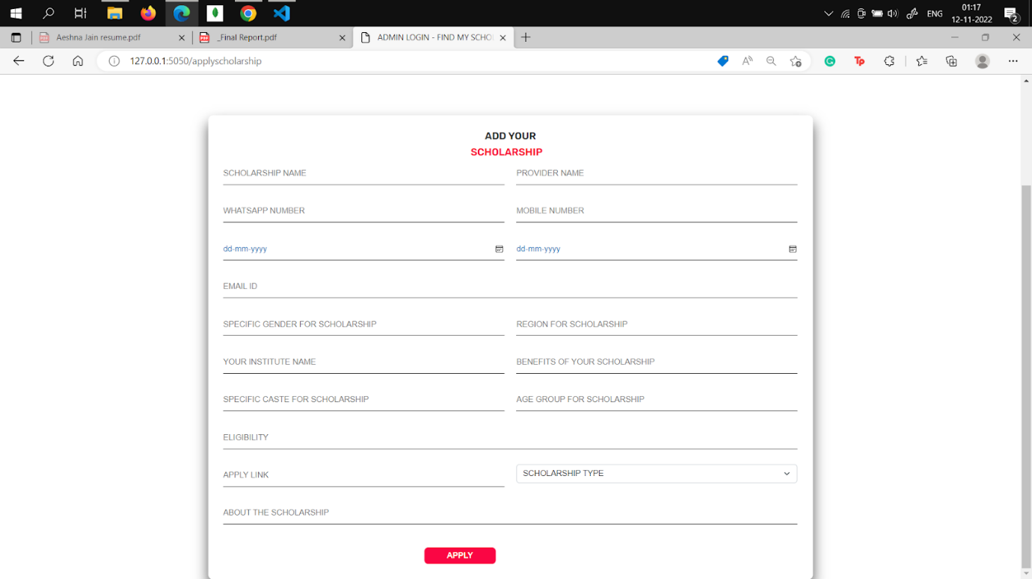

**Figure: 5 Apply For Scholarship Page for private scholarship providers**

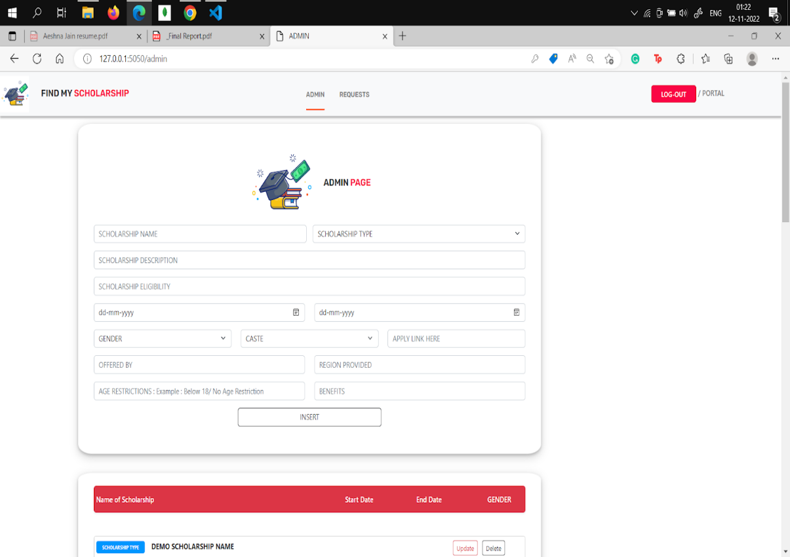

**Figure: 6 Admin Page**

**3.4 Diagrams**

* **Use Case Diagram**

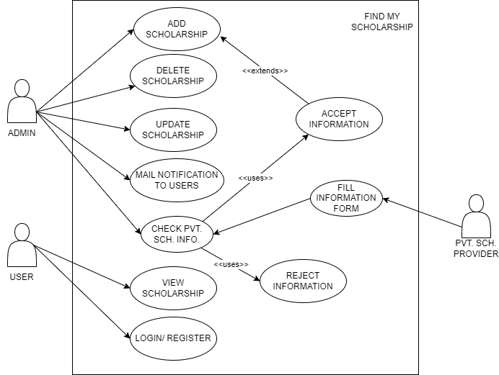

**Figure: 7 UseCase Diagrams**

A use case diagram is a way to summarize details of a system and the users within that system. It is generally shown as a graphic depiction of interactions among different elements in a system. Use case diagrams will specify the events in a system and how those events flow, however, use case diagrams do not describe how those events are implemented.The method creates a document that describes all the steps taken by a user to complete an activity. According to this use case diagram there are three entities - admin,user, private scholarship providers. Their roles and responsibilities are as follows:

* Admin: The person manages all Scholarships and students. It has its user-id password and can change any part of the portal.

* Students- Students can register on the portal and can filter information provided by the portal as per their needs.

* Private Scholarship provider: organizations that want to add their scholarship can add their scholarship on the apply_your_scholarship section.

**Scholarship Management System**

* **Data Flow Diagrams (DFD)**

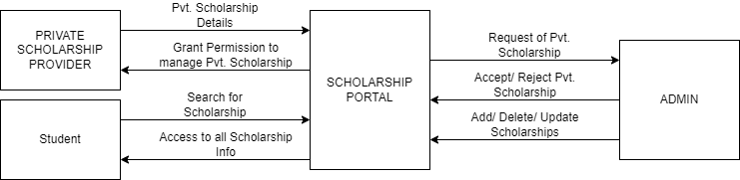

**Figure: 8 Level 0**

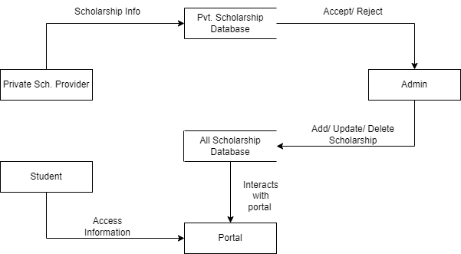

**Figure: 9 Level 1**

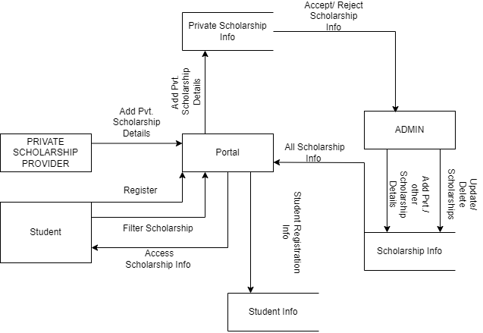

**Figure: 10 Level 2**

A data flow diagram (DFD) is a visual representation of the information flow through a process or system. DFDs help you better understand process or system operation to discover potential problems, improve efficiency, and develop better processes. They range from simple overviews to complex, granular displays of a process or system.Level 0 diagram shows the simplified and primary working of the system. Level 1 shows the detailed form of working and level 2 gives a great insight into the project by describing the functions of how data flows from students to the portal to the administrator.

* **Entity Relationship Diagram**

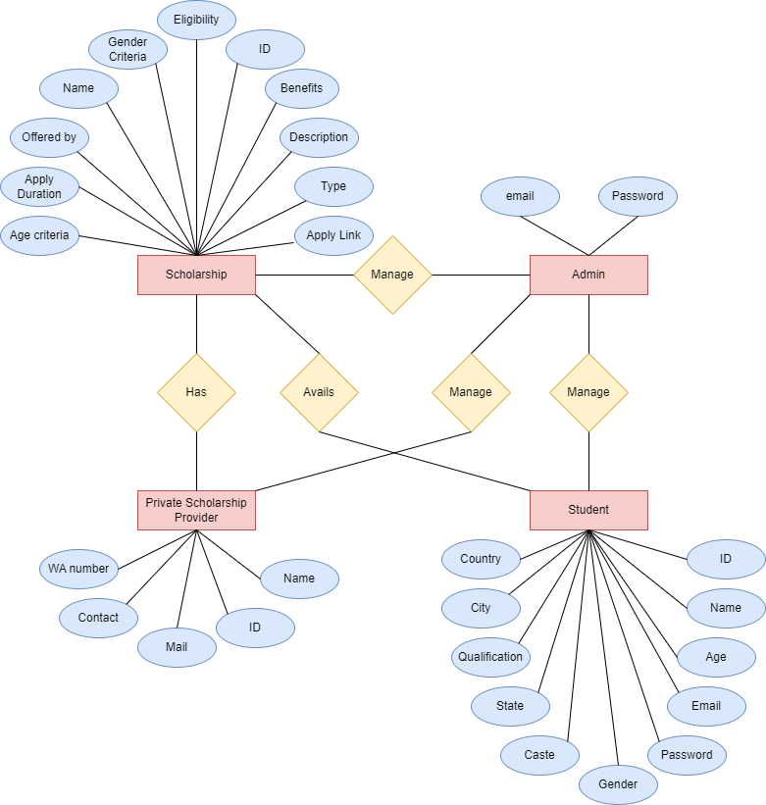

An Entity Relationship Diagram is a diagram that represents relationships among entities in a database. It is commonly known as an ER Diagram. An ER Diagram in DBMS plays a crucial role in designing the database. The ER Diagram is a structural design of the database. It acts as a framework created with specialized symbols to define the relationship between the database entities. ER diagram is created based on three principal components: entities, attributes, and relationships. Here the entities are: Scholarship, Admin, private_scholarship provider and Student. Admin for the portal is fixed and add-ons can be done as per need, scholarships and students are related to each other as students will apply for scholarships so they avail of scholarships. Admin manages every other entity so it is related to each other by relationship “manage”.Private scholarship providers have their scholarships which they can add to the portal by further acceptance of the administrator.

**CHAPTER 4  IMPLEMENTATION**

Implementation

To address the problem of searching many websites for a single scholarship which  results  in a very tedious task and to spread awareness about existing scholarships, this portal is designed. Youth can easily find all types of scholarships including central, state, International and scholarships from some other sources like NGOs. Also, the implementation of the project follows the idea of providing those NGOs and institutes a platform to bring out their ideas and policies and contribute to the education sector of our country.

**4.1 Technique Used**



**4.1.1  HTML 5**

HTML stands for Hyper Text Markup Language. It is the standard markup language for creating web pages. It describes the structure of a web page. HTML consists of a series of elements. HTML elements tell the browser how to display the content.HTML5 is a markup language used for structuring and presenting content on   the World Wide Web. It is the fifth and final major HTML version that is a World Wide Web Consortium recommendation.

**4.1.2 CSS 3**

Cascading Style Sheets (CSS) is a simple mechanism for adding style (e.g., fonts, colours, spacing) to Web documents.CSS3 is the latest evolution of the Cascading Style Sheets language and aims at extending CSS2.1. It brings a lot of new features and additions, like rounded corners, shadows, gradients, transitions or animations, as well as new layouts like multi-columns, flexible boxes or grid layouts.

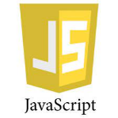

**4.1.3 Javascript**

JavaScript, often abbreviated as JS, is a programming language that is one of the core technologies of the World Wide Web, alongside HTML and CSS.JS or Javascript is used to program the behaviour of web pages. JS libraries and frameworks make website and application development easier with wide-ranging features and functionalities.

**4.1.4 JQuery**

jQuery is a fast, small, and feature-rich JavaScript library. It makes things like HTML document traversal and manipulation, event handling, animation, and Ajax much simpler with an easy-to-use API that works across a multitude of browsers. With a combination of versatility and extensibility, jQuery has changed the way that millions of people write JavaScript.



**4.1.5 Flask**

Flask is a micro web framework written in Python. It is classified as a  microframework because it does not require particular tools or libraries. It has no database abstraction layer, form validation, or any other components where pre-existing third-party libraries provide common functions. Flask depends on the Jinja template engine and the Werkzeug  WSGI toolkit. Additional add-ons in Flask make it ready for web development .

* **Jinja**:

Jinja is a fast, expressive, extensible templating engine. Special placeholders in the template allow writing code similar to Python syntax. Then the template is passed data to render the final document.

* **WSGI**;

WSGI is the Web Server Gateway Interface. It is a specification that describes how a web server communicates with web applications, and how web applications can be chained together to process one request.

* **Werkzeug:**

Werkzeug is a comprehensive [WSGI](https://wsgi.readthedocs.io/en/latest/) web application library. It began as a simple collection of various utilities for WSGI applications and has become one of the most advanced WSGI utility libraries. Werkzeug can instantiate objects for request, response, and utility functions. It can be used as the basis for a custom software framework and supports Python 2.7 and 3.5 and later.



**4.1.6  FlaskSQLAlchemy**

Flask-SQLAlchemy is an extension for Flask  that adds support for SQLAlchemy to your application. It simplifies using SQLAlchemy with Flask by setting up common objects and patterns for using those objects, such as a session tied to each web request, model, and engine.Flask-SQLAlchemy does not change how SQLAlchemy works or is used.

**4.1.7 FLask Mail**

The Flask-Mail extension provides a simple interface to set up SMTP with your Flask  application and to send messages from your views and scripts. Web-based applications typically require the ability to send mail to the user/client. Flask doesn’t have an out-of-the-box solution to send mail. Instead, the Flask-Mail extension makes it easy to establish a simple interface with any email server.



**4.1.8 SQLite**

SQLite is a C-language library that implements a small, fast, self-contained, high-reliability full-featured, SQL database engine. SQLite is the most used database engine in the world. The SQLite file format is stable and cross-platform. SQLite database files are commonly used as containers to transfer rich content between systems and as a long-term archival format for data, There are over 1 trillion (1e12) SQLite databases in active use.

**4.2 Testing**

Testing is the process of evaluation of a system to detect differences between given   input and expected output and also to assess the features of the system. Testing assesses the quality of the product. It is a process that is done during the development process.

The testing process used in the project is Black box testing and white box testing. The whole code is checked and tested by running various test cases, also the functionality is also tested.

**4.2.1 Testing at the front end**

At the registration page all the dropdowns are working fine, all tab clicks are accurate,  confirm password field working fine and the form gets submitted by entering clicks. At login and registration page all the passwords are hidden while entered.  All the measures and test recordings are done by the developer. Cards used in showing information about scholarships are arranged in an effective manner.

**4.2.2 Testing at the backend**

At the backend, all three databases namely student, private scholarship and scholarships are linked and bound to each other. Password confirmation is done successfully. Url validations are also done at the backend and are done successfully. All the CURD operations are working well and contribute towards the good deployment of the project.

***Real-Time Object Detection and Recognition***

**CHAPTER 5 CONCLUSION**

Conclusion



**5.1 Conclusion**

In today’s world, it’s so difficult to manage the information we have, daily a huge amount of data is generated and implemented, and to keep track of that information it's necessary to introduce an information system. This portal is an information system which manages all the information related to scholarships and fixes the problems that youth face, like difficulty in finding appropriate and authorized data at the right time. Education is perhaps [among the most important investments](https://blogs.worldbank.org/education/tertiary-education-essential-opportunity-competitiveness-and-growth) one can make to secure a bright future. It can help one build a network of professional contacts, find better job opportunities, as well as gain financial stability. However, quality education does not come cheap,the increasing cost of education is leaving very limited options to students. Fortunately, scholarships from both public and private sectors are there to provide opportunities to numerous deserving students. Implementation of a system that manages data regarding scholarships and gives a compact and collected form of information reduces man work of arranging a big amount of data and management of information,this makes searching and application work much easier. Earlier when records of these scholarships were stored in the file system manually there were huge chances of incomplete data and corrupted data but the online system reduced those possibilities and made the process smooth for users. The interactive user interface where data is properly arranged makes users feel comfortable and motivated to search for their desired information and make good use of the existing system.

**5.2 Limitations of the Work**

Upon testing and analyzing this product, I found some shortcomings and improvements in this project.

The existing system works for the government and the government of India runs a single portal for all types of scholarships, which is insufficient for accessing and comparing scholarships for youth. So this portal can not submit the data of students to the government of India. Another shortcoming is there should be more filtering options available and colleges must be added to the portal to ease the work of college students.

**5.3 Future Advancements**

According to planning, a recommendation system needs to be added so, a module of the same should be added so that users get recommendations about the scholarships which are either accessed by most of the students or those scholarships which best suit their profile. Also, the notification system needs to be improved so the work on these modules will be taken for future advancements. 

**Bibliography**

[1] Forat Falih Hasan: ”A Review Study of Information Systems” International Journal of Computer Applications(0975 – 8887) Volume 179 – No.18, February 2018.

[2] Sauser, Eric Irvin, "Scholarship management system" (2011). Honors Program    Theses. 20.

[3] Adil Mahmoud Mohamed Mahmoud, Asim Seedahmed Ali Osaman: “An Automated WebBased System for Follow up on the Scholarships of Faculty Members” IJCSNS International Journal of Computer Science and Network Security, VOL.19 No.10, October 2019.

 [4]  Burton R.Clark : ”The higher Education system” University of  California    Press,  Ltd. London, England

***38***

***Real-Time Object Detection and Recognition***

1. S. K. Nayar, S. A. Nene and M. Hiroshi, "Real-Time 100 Object Recognition System," in *IEEE International Conference*, 1996.

1. A. Adam, E. Rivlin, S. Ilan and D. Reinitz, "Robust Real-Time Unusual Event Detection Using Multiple Fixed-Location Monitors," in *IEEE*, 2008.

1. C. Bahlmann, Y. Zhu, R. Vishwanathan, M. Pelkoffer and T. Koehler, "A System for Traffic Sign Detection, Tracking, and Recognition Using Color, Shape, and Motion Information," in *IEEE*, 2005.

1. M. Betke, E. Haritaoglu and L. S. Davis, "Real-time multiple vehicle detection and tracking from a moving vehicle," *Machine Vision and* *Applications,* p. 12, 2000.

1. Q. Chen, N. D. Georganas and E. M. Petriu, "Real-time Vision-based Hand Gesture Recognition Using Haar-like Features," in *IEEE* *Conference*, 2007.

1. R. Cutler and L. S. Davis, "Robust Real-Time Periodic Motion Detection, Analysis, and Applications," *IEEE transactions on Pattern* *Analysis and Machine Intelligence,* 2000.

1. J. Heikkila and O. Silven, "A real-time system for monitoring of cyclists and pedestrians," *Image and Vision Computing,* 2004.

1. D. Maturana and S. Scherer, "VoxNet: A 3D Convolutional Neural Network for Real-Time Object Recognition," in *IEEE International* *Conference*, 2015.

1. C. Papageorgiou and T. Poggio, "A Trainable System for Object Detection," *Internation Journal of Computer Vision,* 2000.

***39***

***Real-Time Object Detection and Recognition***

1. J. Redmon, S. Divvala, R. Girshik and A. Farhadi, "You Only Look Once: Unified, Real-Time Object Detection," in *IEEE conference on Computer* *Vision and Pattern Rocgnition*, 2016.

1. J. Shotton, A. Fitzgibbon, M. Cook, T. Sharp, M. Finocchio, R. Moore, A. Kipman and A. Blake, "Real-Time Human Pose Recognition in Parts from Single Depth Images," *Computer Vision and Pattern Recognition,* 2011.

1. K. P. A. Menon, "Management of Agriculture and Rural Development Programme: Problems and Prospects, India," *J Extension Education,* vol. 21, no. 1, pp. 94-98, 1985.

1. S. Hinterstoisse, V. Lepetit, S. Ilic, P. Fua and N. Nassir, "Dominant Orientation Templates for Real-Time Detection of Texture-Less Object," in *IEEE Conference*, 2010.